2012 New England Regional Concrete Canoe Competition Student Conference

February 12, 2012

Dear New England Regional Concrete Canoe Team:

First of all, thank you all for getting your registration payments in on time! I apologize for the delay in Mailer II, but it has enabled us to give you all more information. This is your 2012 New England Regional Concrete Canoe Competition Student Conference Mailer II, the second of three packets to be sent to each of the participating schools. Please read carefully through this packet and distribute copies to the appropriate chairpersons in your Chapter. Do not throw away this mailer! The information that is given here may not be repeated in subsequent mailers. Enclosed you will find the following updates:

♦ Design Paper due date
♦ Locations have been added to the schedule
♦ Parking details/ Maps

If you have any questions, feel free to contact us at the e-mail address: 2012NewnglandCCC@gmail.com All questions and answers concerning the events, rules, etc. will be posted on our web site: 2012NewEnglandCCC.weebly.com. We will do everything possible to answer your questions in a timely manner, but please be patient – we are learning as we go.

We look forward to seeing you in the spring!

Sincerely,

Anabelle Allen
President, ASCE Student Chapter
University of New Hampshire

2012 New England Regional Concrete Canoe Competition Student Conference

Design Paper

DUE: March 28th by 5pm

As outlined in the rules, we must receive 6 bound copies of your team’s design paper by the due date of March 28th by 5pm.

Mail to:

Civil Engineering Department
University of New Hampshire
Kingsbury Hall
33 Academic Way
Durham, NH 03824
Attn: ASCE

2012 New England Regional Concrete Canoe Competition Student Conference

Updated Schedule

Friday, April 20th
2-5pm: Registration and set up in Morse Hall (parking area 1)
5-6pm: Cross Section and Poster Viewing in Morse Hall
6-9pm: Presentations and Pizza dinner in DeMeritt Hall Rm 112
9pm: Captain’s Meeting to follow DeMeritt Hall Rm 112

Saturday, April 21st
7-9am: Arrival at Ayer’s Lake Campground and canoe setup
9-11am: Display Judging and Sink Test
11am-12pm: First Round of Races
12pm: Lunch
12-5pm: Racing
5-8pm: Dinner back at the UNH's dining hall (or wherever you choose)
8-9pm: Awards Ceremony with hot beverages and dessert at Holloway Commons with guest speaker from ASCE (parking area 2)

2012 New England Regional Concrete Canoe Competition Student Conference

Parking

Parking Area 1 is in the Visitor’s section of H lot. Parking Passes will be provided.
Parking Area 2 Options are C lot and B lot. It will be free open parking in these lots for dinner and the awards ceremony Saturday night.

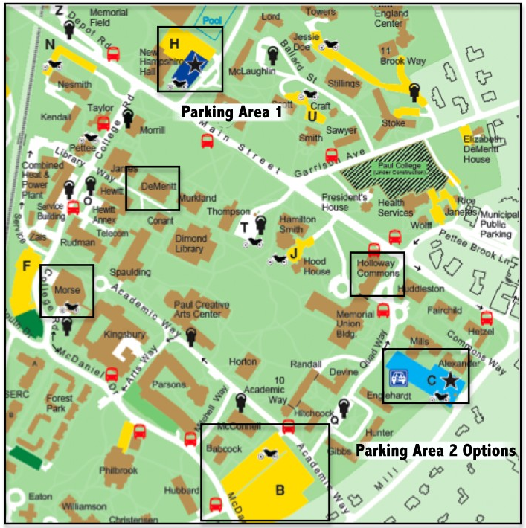
2012 New England Regional Concrete Canoe Competition Student Conference

Ayer’s Lake Map

Please note, if you Google Ayer’s Lake Campground in Barrington, NH it will give you the approximate road location, but the road was renumbered recently and the maps haven’t been updated. Instead, use the coordinates:
43.248508,-71.049603
http://maps.google.com/maps?client=safari&rls=en&q=43.248508,-71.049603&oe=UTF-8&um=1&ie=UTF-8&hq=&hnear=0x89e28f82659f4061:0x1bac184b7d98c78b,%2B43°+14'+54.40%22,+-71°+2'+58.42%22&gl=us&ei=ZnY4T-SAKOfg0QH0yKGXAg&sa=X&oi=geocode_result&ct=image&resnum=1&ved=0CCEQ8gEwAA

