2012 New England Regional Concrete Canoe Competition Student Conference

March 26, 2012

Dear New England Student Chapter:

This is your 2012 New England Student Conference – Concrete Canoe Mailer III, the third of three packets to be sent to each of the participating schools. Please read through this packet carefully and distribute copies to the appropriate chairpersons of your Chapter. Do not throw away this mailer! The information provided here may not be repeated in subsequent mailers. Enclosed you will find the following information:

- Design Paper submittal reminder
- Final Schedule – PLEASE NOTE THAT MINOR CHANGES HAVE BEEN MADE
- Updated Parking Instructions (# of passes needed due April 10th)

Important:
- The deadline for the design papers March 28th.
- Please get all T-shirt sizes in as soon as possible.
- If you plan to go to the local bars, please do not drink and drive. The local taxi service is Portsmouth Taxi. Their website is http://www.portsmouth-taxi.com/ and phone number is (603) 431-6811.

If you have any questions, feel free to contact us at the e-mail address: 2012NewnglandCCC@gmail.com All questions and answers concerning the events, rules, etc. will be posted on our web site: 2012NewEnglandCCC.weebly.com. We will do everything possible to answer your questions in a timely manner, but please be patient – we are learning as we go.

We look forward to seeing you soon!

Sincerely,

Anabelle Allen
President, ASCE Student Chapter
University of New Hampshire
2012 New England Regional Concrete Canoe Competition Student Conference

Design Paper

DUE: March 28th by 5pm

As outlined in the rules, we must receive 6 bound copies of your team’s design paper by the due date of March 28th by 5pm.

Please mail to:

Civil Engineering Department
University of New Hampshire
Kingsbury Hall
33 Academic Way
Durham, NH 03824
Attn: ASCE

2012 New England Regional Concrete Canoe Competition Student Conference

Updated Schedule

Friday, April 20th
2-4:30pm: Registration and set up in Morse Hall (parking area 1)
4:30-5pm: Captain’s Meeting in Morse Hall
5-6pm: Cross Section and Poster Viewing in Morse Hall
6-9pm: Presentations and Pizza dinner in DeMeritt Hall Rm 112

Saturday, April 21st
7-9am: Arrival at Ayer’s Lake Campground and canoe setup with Breakfast
9-11am: Display Judging and Sink Test
11am-12pm: First Round of Races
12pm: Lunch
12-5pm: Racing
5-8pm: Dinner back at the UNH's dining hall (or wherever you choose)
8-9pm: Brief Awards Ceremony with hot beverages and dessert at Holloway Commons with guest speaker from ASCE (parking area 2)

2012 New England Regional Concrete Canoe Competition Student Conference

Parking

- Parking Area 1 is in the Visitor’s section of H lot. Parking Passes will be sent 1 week prior to competition. Please submit how many parking passes your team will need by April 10th to Anabelle via Email. All trailers will have to be parked in Mast Lot. (MAP for Mast Lot)
- Parking Area 2 Options are C lot and B lot. It will be free open parking in these lots for dinner and the awards ceremony Saturday night.

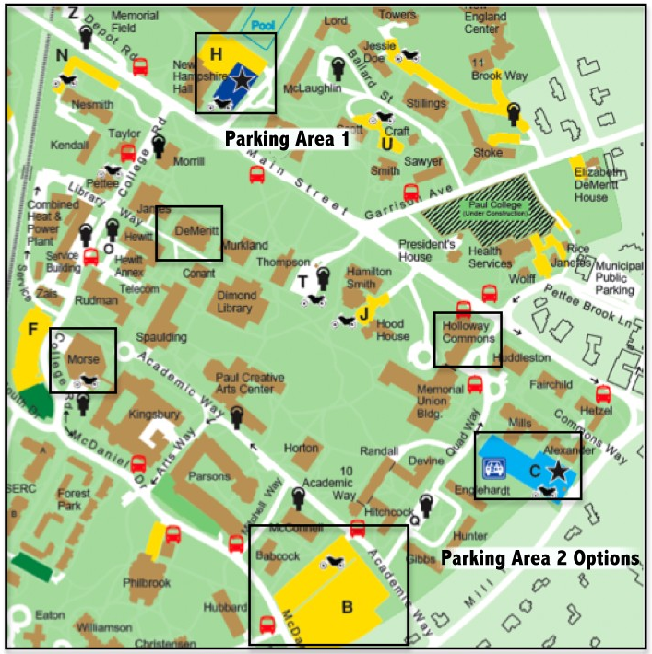
2012 New England Regional Concrete Canoe Competition Student Conference

Ayer’s Lake Map

Please note, if you Google Ayer’s Lake Campground in Barrington, NH it will give you the approximate road location, but the road was renumbered recently and the maps haven’t been updated. Instead, use the coordinates:
43.248508,-71.049603 (Click here for map)

Directions for parking at Ayer’s Lake Campground will be discussed at the Captain’s Meeting the first day of competition.

